David Pizzolongo and Yassine Ibhir Mar. 29, 2021

Project 1 Report

Diagrams:

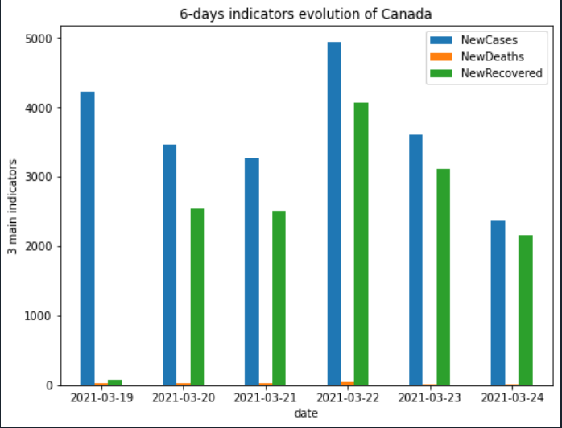

In the first bar chart results, the statistics show that Canada’s coronavirus situation is unstable, with peaks on March 19 and March 22. For the majority of the days, there is almost the same number of new cases as new recovered, demonstrating that the spread of the virus is still visible and if it continues, there will be a continuous flow of people becoming ill and very little progress will be made. However, very recently, we have been heading in the right direction, with under 4000 new cases in the last three days and low rates of mortality.

This detailed analysis was very interesting and thought-provoking since the spread of the disease still remains dominant, but the provincial government remains focused on gradually removing important safety measures.

Other remarks:

At the beginning, we encountered some difficulties in merging our code, as we were using separate branches and working with different code. Therefore, we decided that it would be better to work together, synchronously on the different parts of project (database, scraping, file io and data science), and to use our personal branches for code that is not completely implemented/tested. We found that this method was very productive.